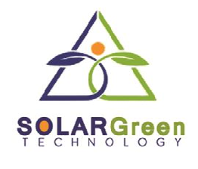

SOLAR GREEN TECHNOLOGY


technosolargreen@gmail.com Ajmer, Rajasthan

+91-7610000632 GSTIN: 08BLWPA1147G1Z3

EPC PROPOSAL FOR 325 KW GRID TIED SOLAR POWER PLANT

CLIENT: Vishwakarma Health Care DATE : 02-02-2026
Ajmer, Rajasthan. Quotation No. : SGT/2026/02/B09

Respected Sir,

We thank you for your interest evinced in us and are happy to partner with you in your solar aspirations. Based on our discussions, we are pleased to provide our EPC offer for Installation and commissioning of grid tied Solar Power Plant mentioned on the next page including the list of materials used in our project.
We ensure you that our work is professional and of the highest quality you will find in this price range, we can also assure and guarantee that this project will be of utmost priority for us with
timely services and workmanship.
Thanking you.

Warm Regards,

Form Solar Green Technology
Ajmer, Rajasthan.

Vardhman Aameria
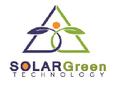
+91-7610000632

SITE VIEW BEFORE SOLAR PALNT AND AFTER SOLAR PLANT

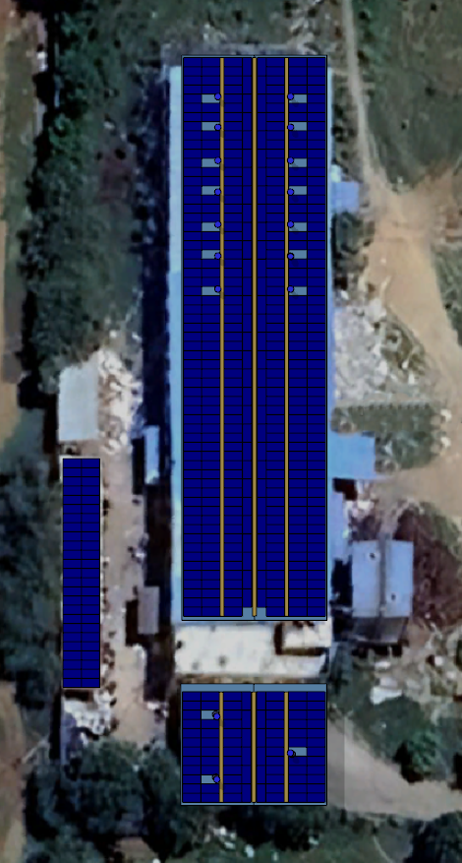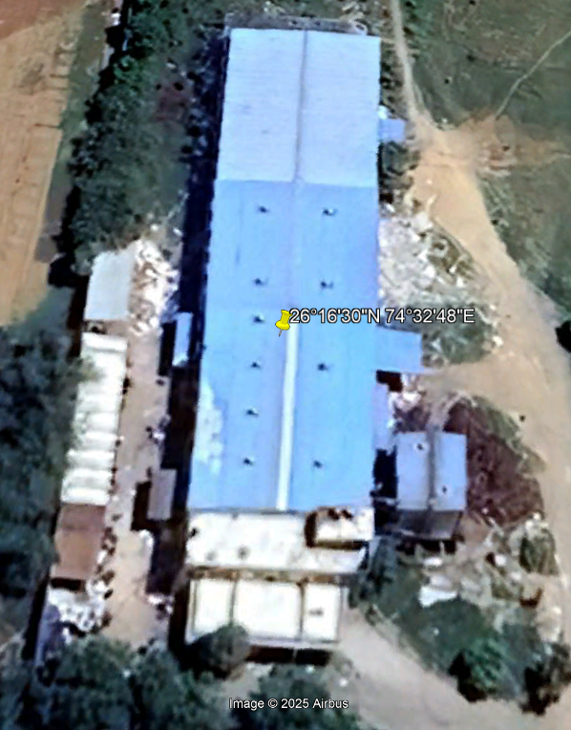

QUOTATION (325 KW – Panels with 250 KW inverter)

S.No. | DESCRIPTION | CAPACITY  ( Watt ) | RATE/ WATT | PRICE ( ₹ )  (Excl. GST) | PRICE ( ₹ )  Incl. GST
1 | Supply of equipments and installation & commissioning | 325090 Wp | ₹ 25.18/WATT | ₹ 8,187,374.50 | ₹ 8,916,050.60

TERMS & CONDITIONS

- The price is inclusive of applicable taxes and duties.
- Prevailing applicable 5 % (70%) GST on the Supply and 18 % (30%) GST on the Installation and commissioning.
- Average GST – 8.9 %

TERMS OF PAYMENT

• 20% Advance with Work Order.
• 40% After Delivery and Installation of Structure and earthing.
• 20% After Delivery of modules and Electrical wiring Material.
• 15% After Delivery of all material.
• 5% After successfully commissioning of Project.

BILL OF MATERIALS

Material | Details | Quantity | Warranty
Panels | RENEWSYS- 590wp Bi-Ficial | Monocrystalline –  325090Watt – 590 watt/Panel = 551 Panels | 12 years product warranty and 25 years linear power warranty
Inverter | Sungrow Inverter | 250 KW - 3 Phase | 10/7 years warranty by the manufacturer
Module Mounting  Structure | AL.  MONO RAIL 300*125MM | 325 KW Structure Including GI Pipe | 5 years from the date of commissioning.
DC cable | Polycab Type 1:- 4 sq mm Tin coated Cu | As required on site | 1 Year  1 Year
AC Cable | Al Armored wire – 3.5 core , Polycab wire- 300 sq mm | As required on site | 1 Year  1 Year
DCDB | L&T / Polycab – 32 in 32 out with1000v spd each | As required on site | 1 Year  1 Year
ACDB | L&T / Polycab – 2 in 1 out with 630 Amps breaker | As required on site | 1 Year  1 Year
MC4 connector | Staubli or Lenoir Equivalent | As required on site | 1 Year  1 Year
Wire Conduits | External: Gi Cable tray ; Internal: Gi Cable tray and Upvc Conduits supported with clamps / stands / cable tray at appropriate places | As required on site | 1 Year  1 Year
Protection | Lightening Arrestor: ESE Type | As required on site | 1 Year  1 Year
Protection | Copper Gel Earthing  (51mm Dia) 9 no. | As required on site | 1 Year  1 Year
Protection | Cu wire down-conductor  06 sqmm for structure  04 sqmm Module to Module Earthing  25 sqmm for Inverter and Acdb  35 sqmm for L.A | As required on site | 1 Year  1 Year
Online Monitoring | In built (Internet to be provided by the client up to the inverters) |  | 1 Year  1 Year
DG SYCHRONISE | Solar Power Plant is connected with DG | As required on site | 5 year

SCOPE OF WORKS:

- Installation and Construction of the Project with associated civil and electrical installations up to AC Distribution Board provided along with solar power plant, according to design provided.
- Civil works of structure via riveting for installation of modules and electrical equipment.
- Solar Panel Modules mounting & installation on the structure.
- Installation Solar Inverters, AC DB, DC DB cabling and associated structural & electrical items.
- LA Installation , Earth pit chamber construction,
- Plant earthing work with GI Strips.
- LT Panel installation & LT Cabling beyond AC Distribution Board to the interconnection point LT Panel / MV Panel.
- Testing and commissioning of individual equipment and completion of solar plant upto AC Distribution Board

CLIENT SCOPE:

- Security of Material: On delivery of materials to buyer’s site in good condition, the buyer shall be responsible for safety & security of the system till handing over of the same to our designated personnel for installation.
- Security of personnel: In case there are social disturbances in the buyer’s site not attributable to us, the buyer shall resolve the same at its own risk & cost, for smooth execution of the project by us. In such case, the buyer shall provide safety & security to our designated personnel working at site. Any delay in execution due to social disturbances at site shall be attributable to the buyer and not compensated by us. Further, any damage to the system due to social disturbances/vandalism at site shall be compensated by the buyer.
- Leveling of land: If the installation is on Land, cleaning and leveling of land to make it suitable for the installation if in the scope of the client.
- Net Metering/Load Increasing: As per the Discom Guidelines (TATA Power/ AVVNL/JVVNL) net metering is an arrangement between the client and the Discom (TATA Power/ AVVNL/JVVNL) and it remains under client’s scope. All the government fees and agreement charges have to be deposited by the client regarding net-metering and load enhancement. We will only assist in the procedure, paper work and liaising.

SOME OF OUR PROJECTS:

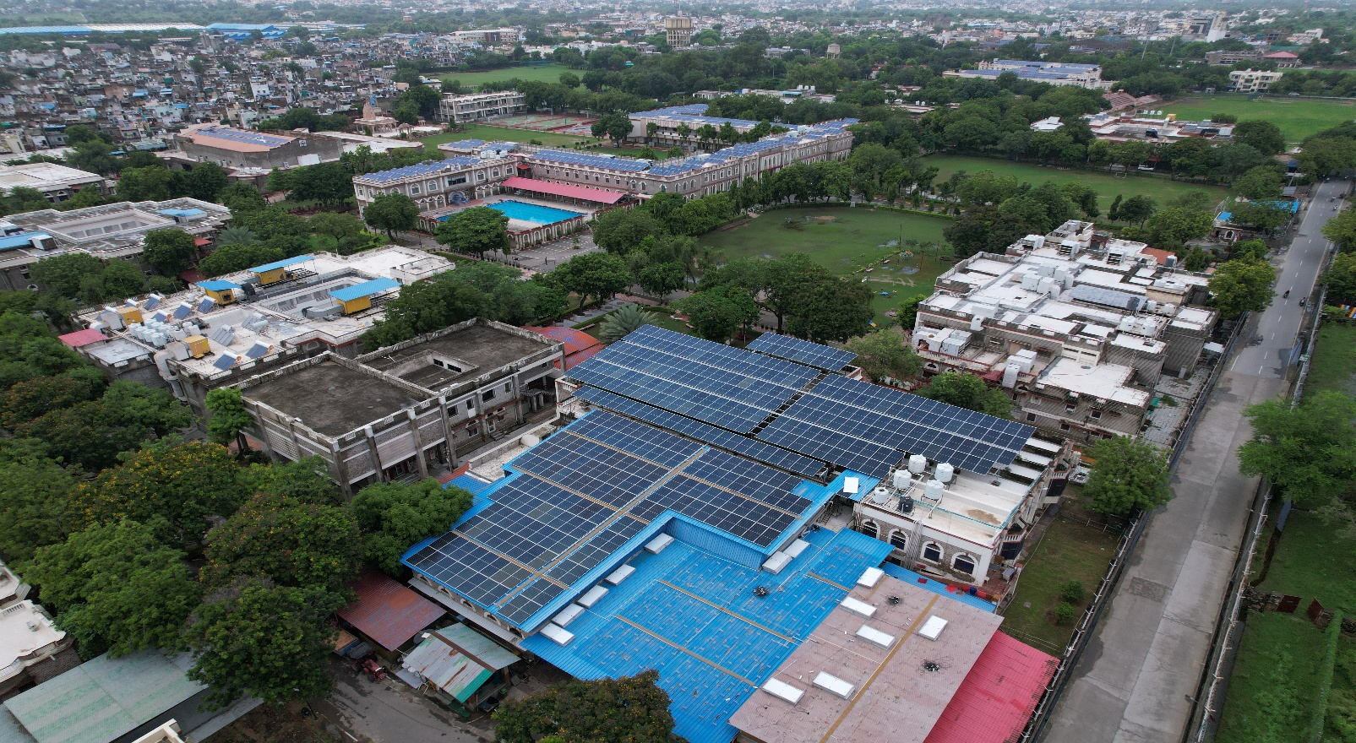

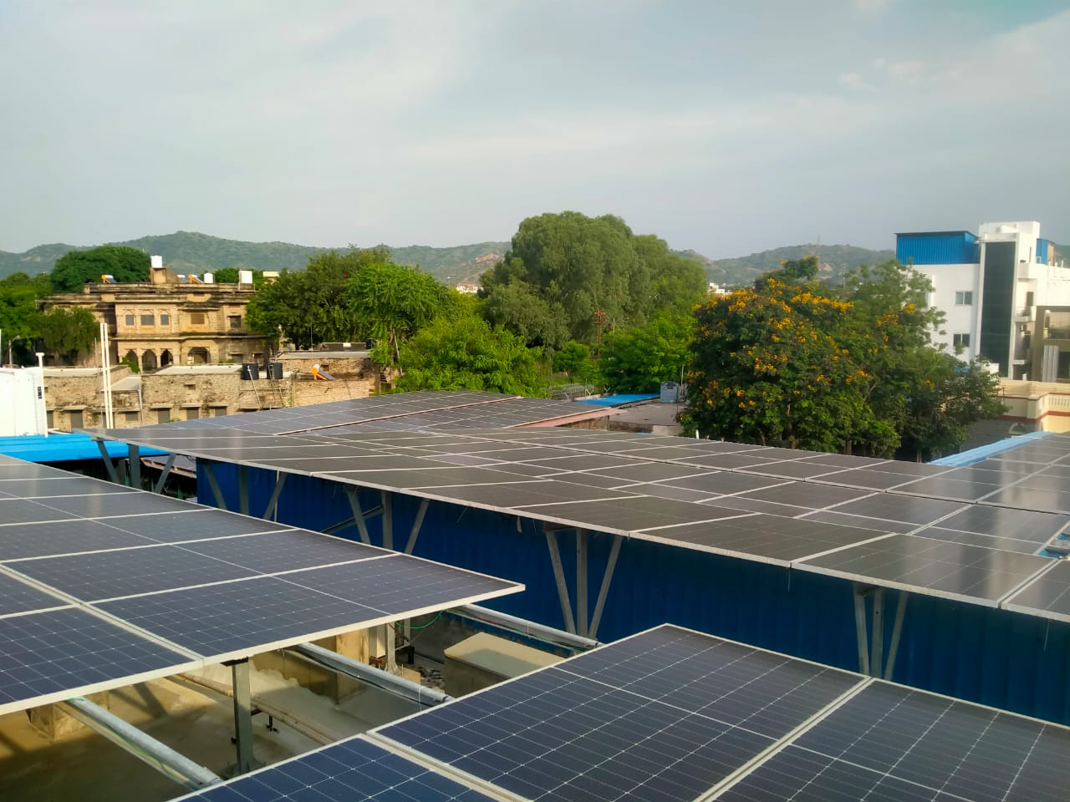
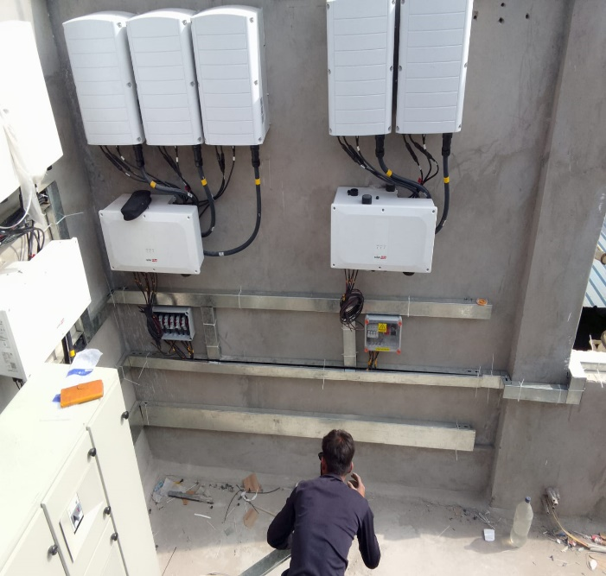

Project Name: EPC- Mayo College Girls School, Ajmer
Project Capacity: 300 KW
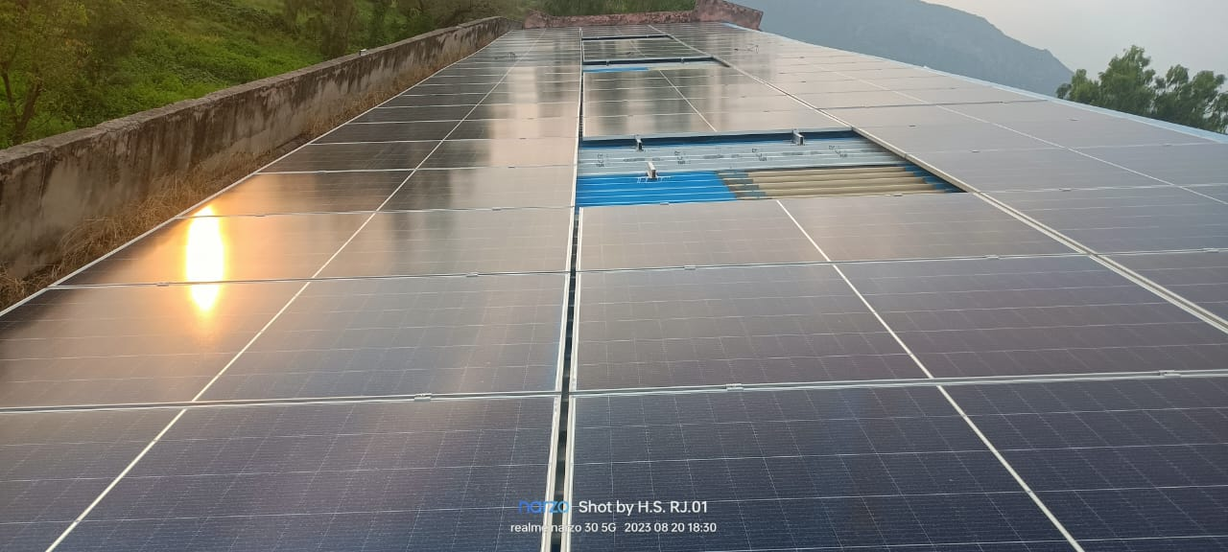
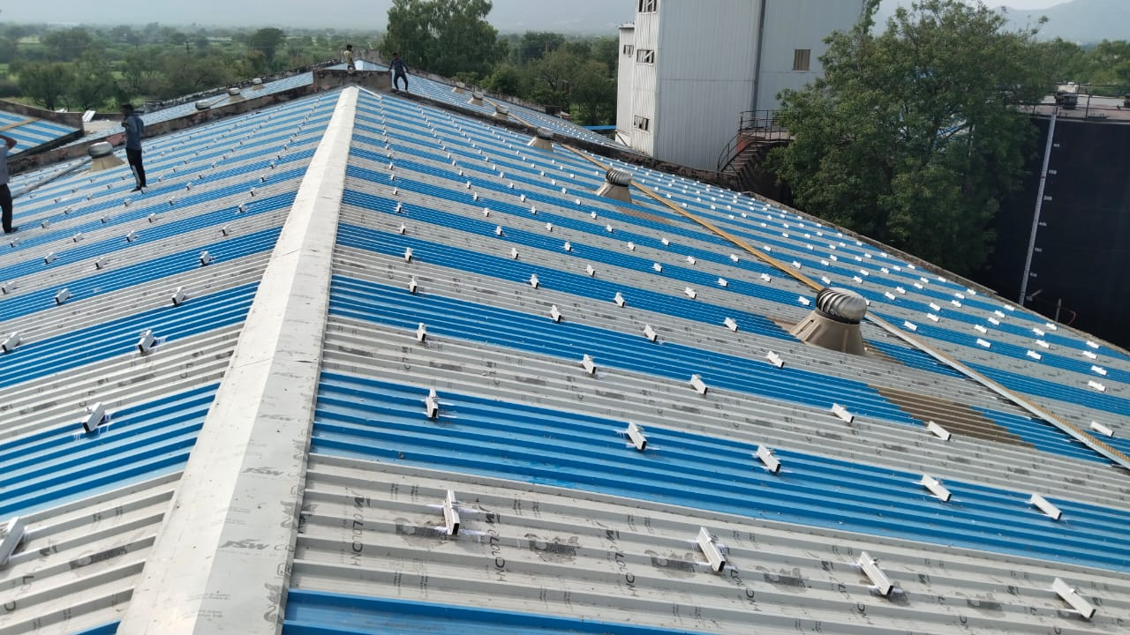

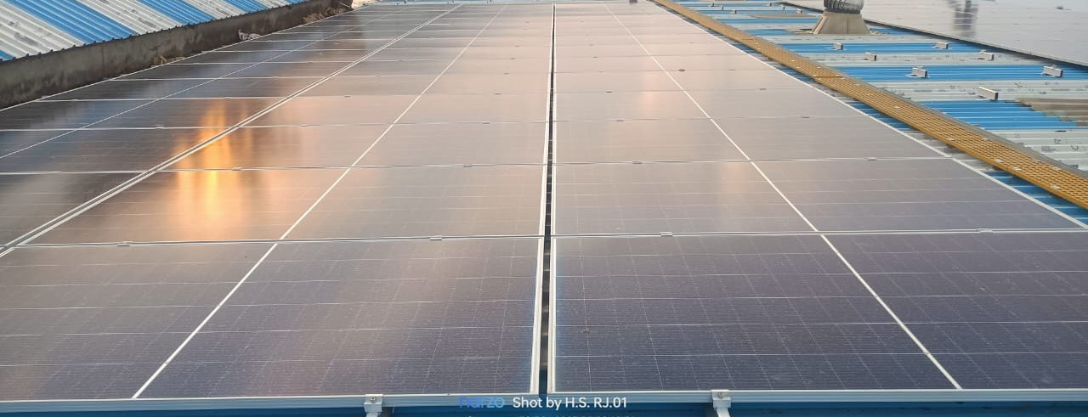

Project Name: EPC- SARAS Cattle feed Dairy Ajmer Project
Project Capacity: 600 KW
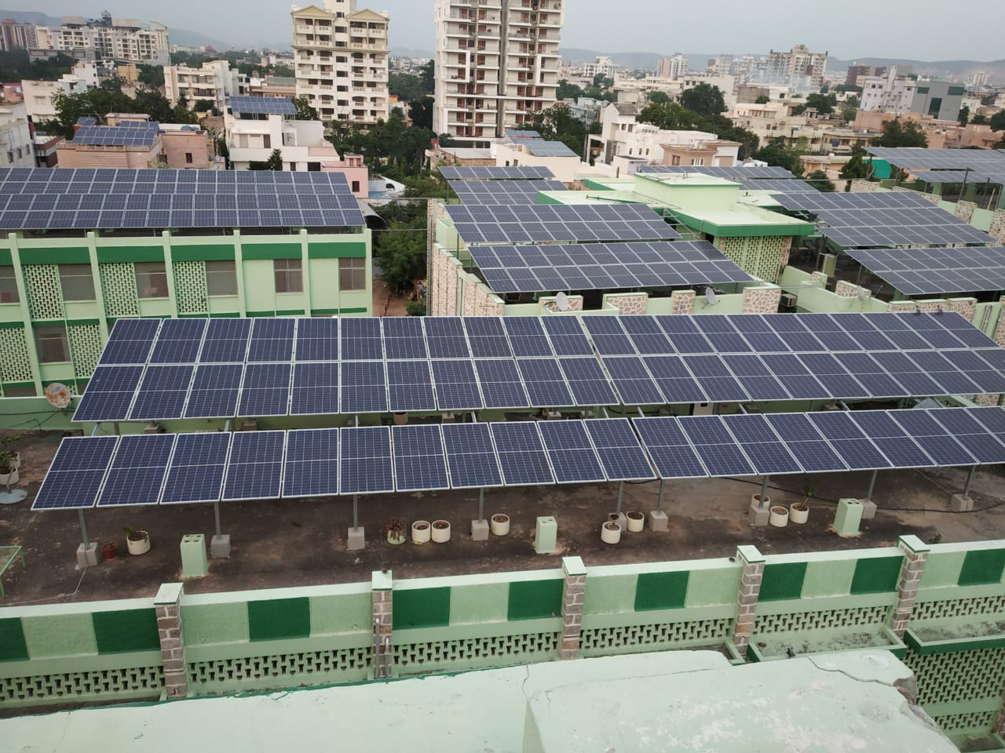

Project Name: INC - Durlab ji Hospital, Jaipur Project
Project Capacity: 300 KW

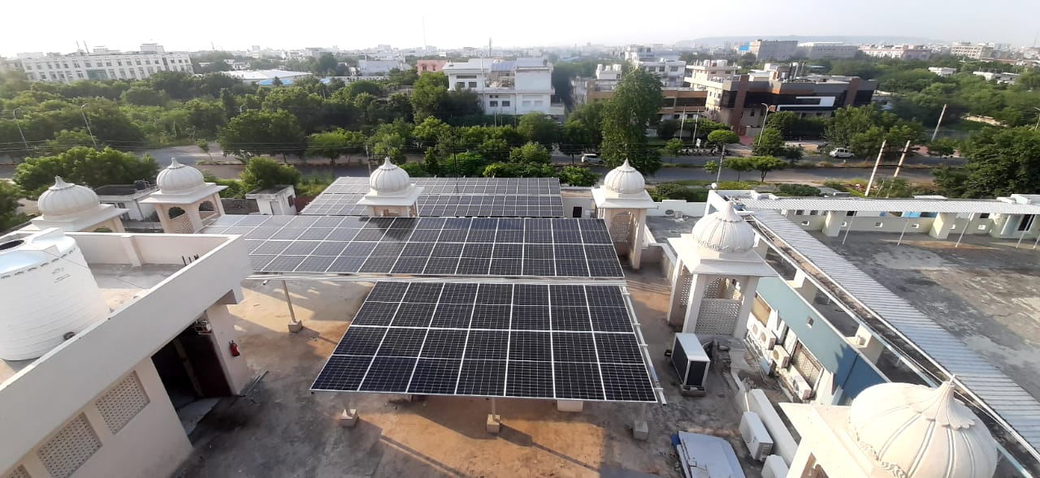
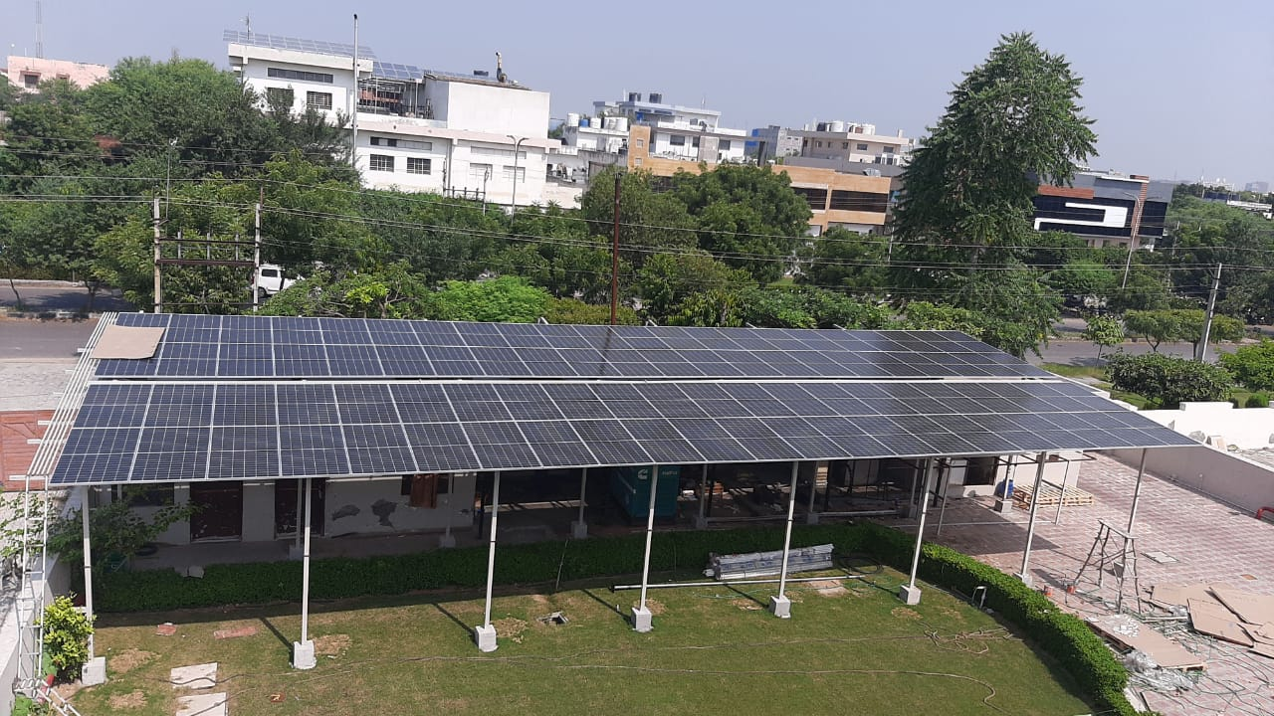
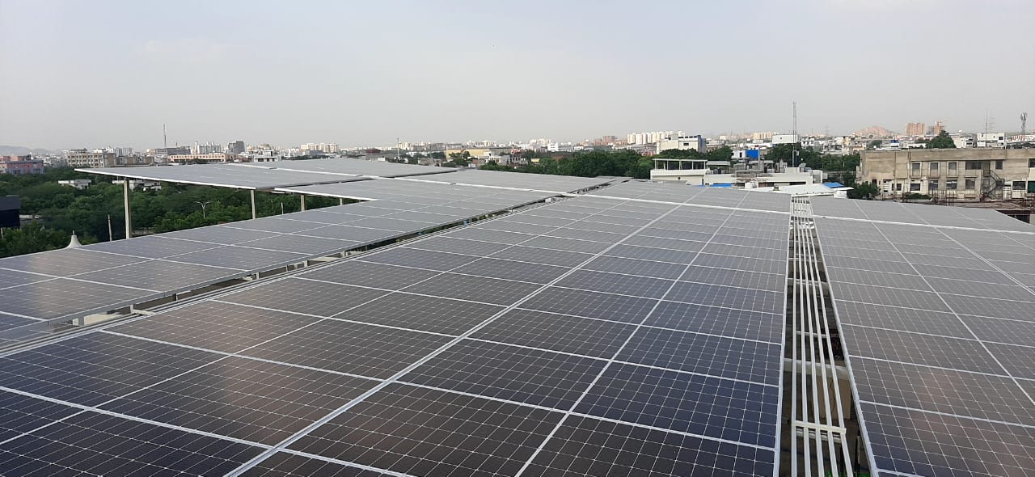

Project Name: INC- Jwellery Zone, Jaipur Project
Project Capacity: 100 KW
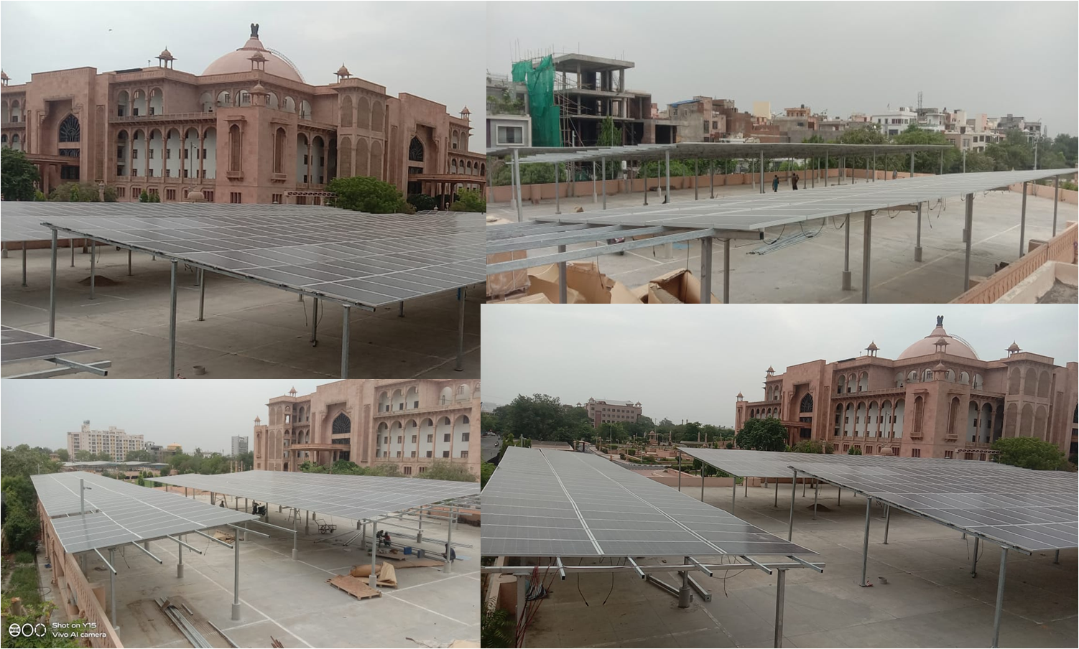

Project Name: INC- Vidhan Sabha, Jaipur Project
Project Capacity: 600 KW

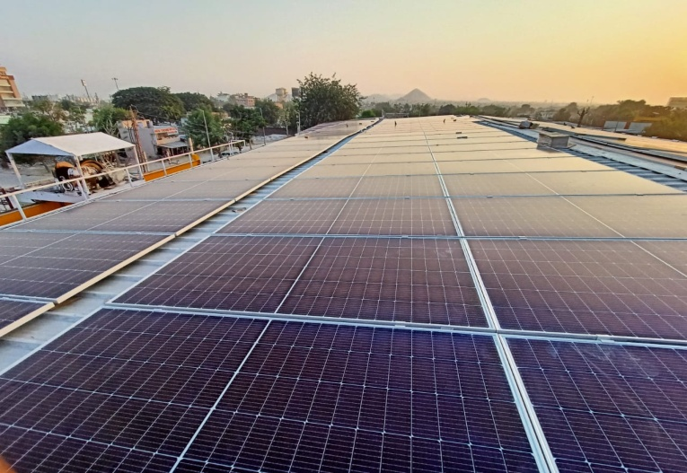
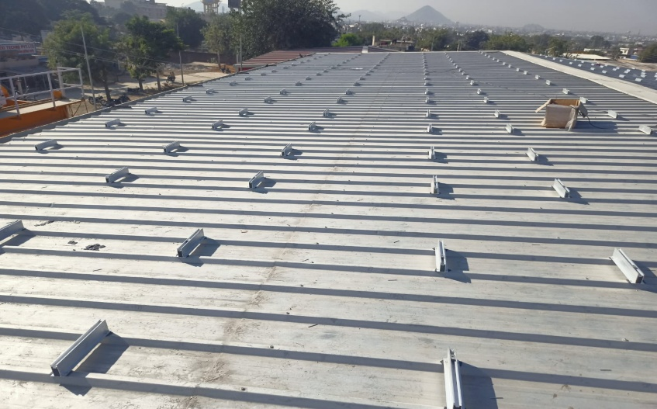

Project Name: EPC -Mahesh Marbles, Kishangarh Project
Project Capacity: 65 KW

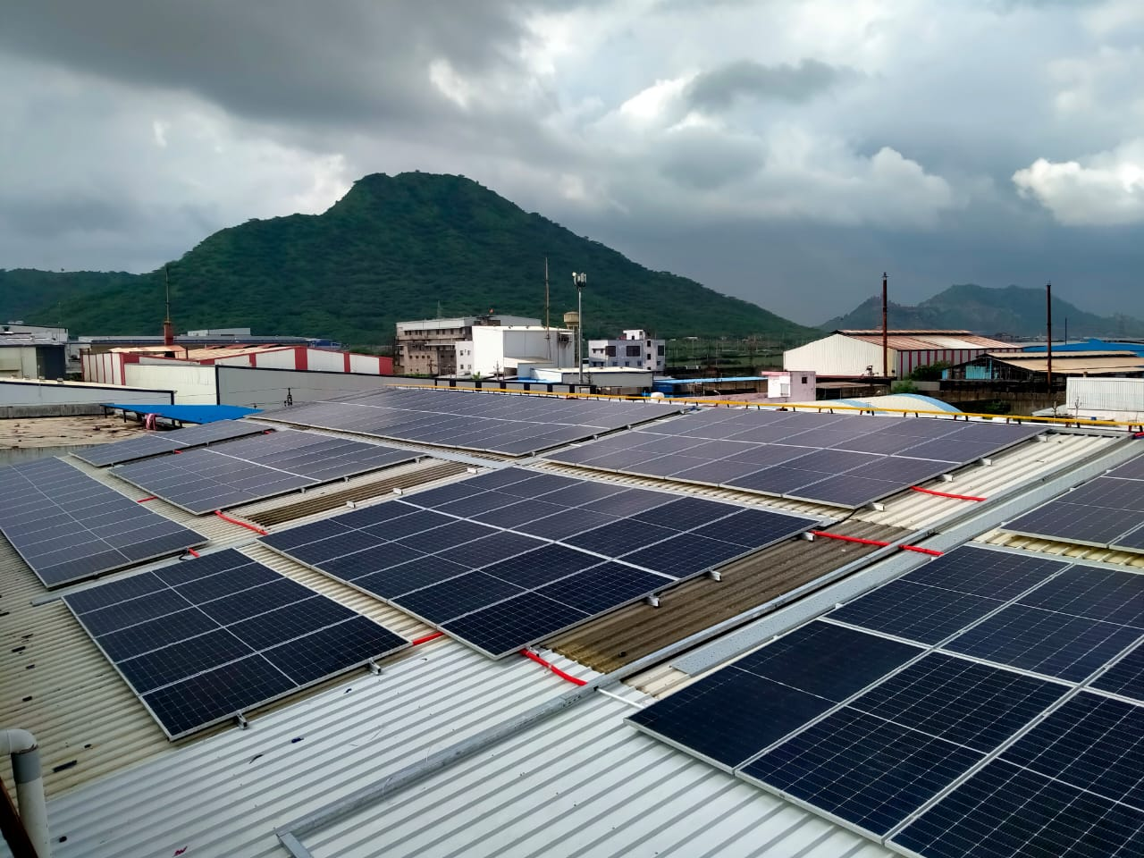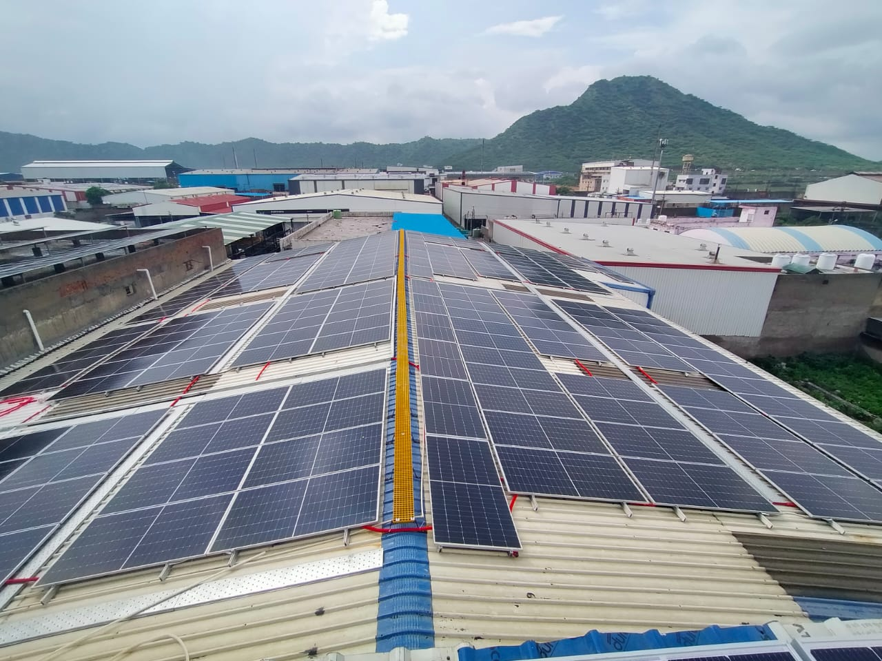

Project Name: EPC- Mahaveer Group Palra Industries area Ajmer
Project Capacity: 490kw

